Tree Notes

Name:__________________ Period______

There are 2 main types of trees!
1._________________________________
2._________________________________

Coniferous
1. _____________________________________________________
2. Leaves always stay green
3. Leaves are ____________________________________________

Coniferous trees have 3 leaf types

Deciduous
1. Leaves _________________________________
2. Lose __________________________________
3. Broad leaves

Deciduous leaf parts
1. ________________ – The main part of the leaf
2. Vein – vascular tissue of a leaf
3. Midrib – the middle vein
4. Petiole – the base of the stem of a leaf
5 Node – where the leaves grow out of the branch

2 Different types of plant/tree families
_____________________ ______________________
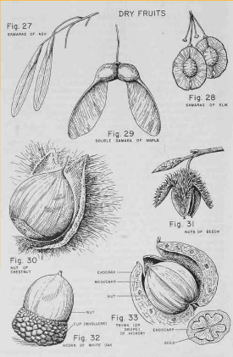

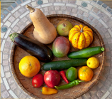
_____________________ _____________________

BASSVLEGS
Pneumonic device to help remember the steps to correctly identify a tree

B
____________________
The color and texture on twigs
Example: _____________________________________

A
_________________________________________________________
_______________ – leaves come out one at a time
Opposite – Leaves come out two at a time
_______________– Leaves come out more than 2

S
___________________________________________________________
- i. Simple –
  - ______ petiole / _____ blade
- ii. Pinnately compound –
  - ______ petiole / __________ blades
- iii. Bipinnately compound-
  - __________ petiole / _______small stems / __________ blades
- iv. Palmately compound
  - ________ petiole / looks like _____________ on hand

S
________________________________________________________
- i. Shape of tree without leaves

V
________________________________________________________
- i. _____________________ –
  - center vein with others branching
- ii. _____________________ –
  - veins run parallel to each other
- iii. _____________________ –
  - veins come out of 1 spot like fingers

L
______________________________________________
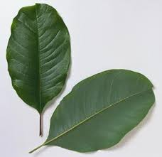
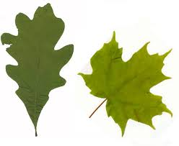

__________________ __________________

E
___________________________________________
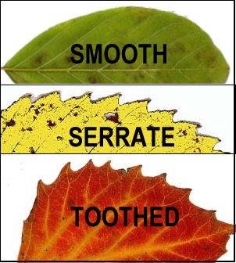
i. ______________________
ii. ______________________
iii. _______________________

G
__________________________
i. ______________ and _________________ of one blade
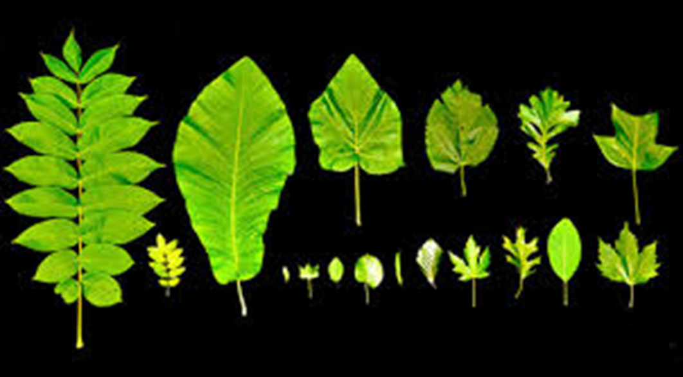
ii. measured in __________________

S
________________________________
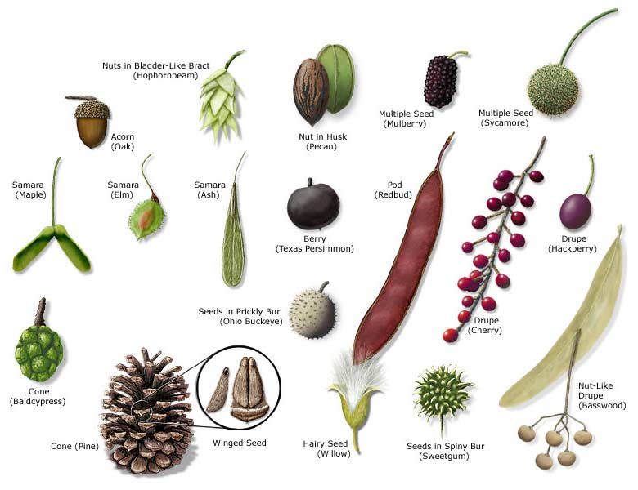
i. Describe and draw/rub if possible

